How to organize a Town Hall Meeting

Prepared by Fred Southwick (chapter founder and leader of Right Care Gainesville), edited by Stephanie Aines (RCA Director of Organizing) and Judith Garber (RCA Communications)

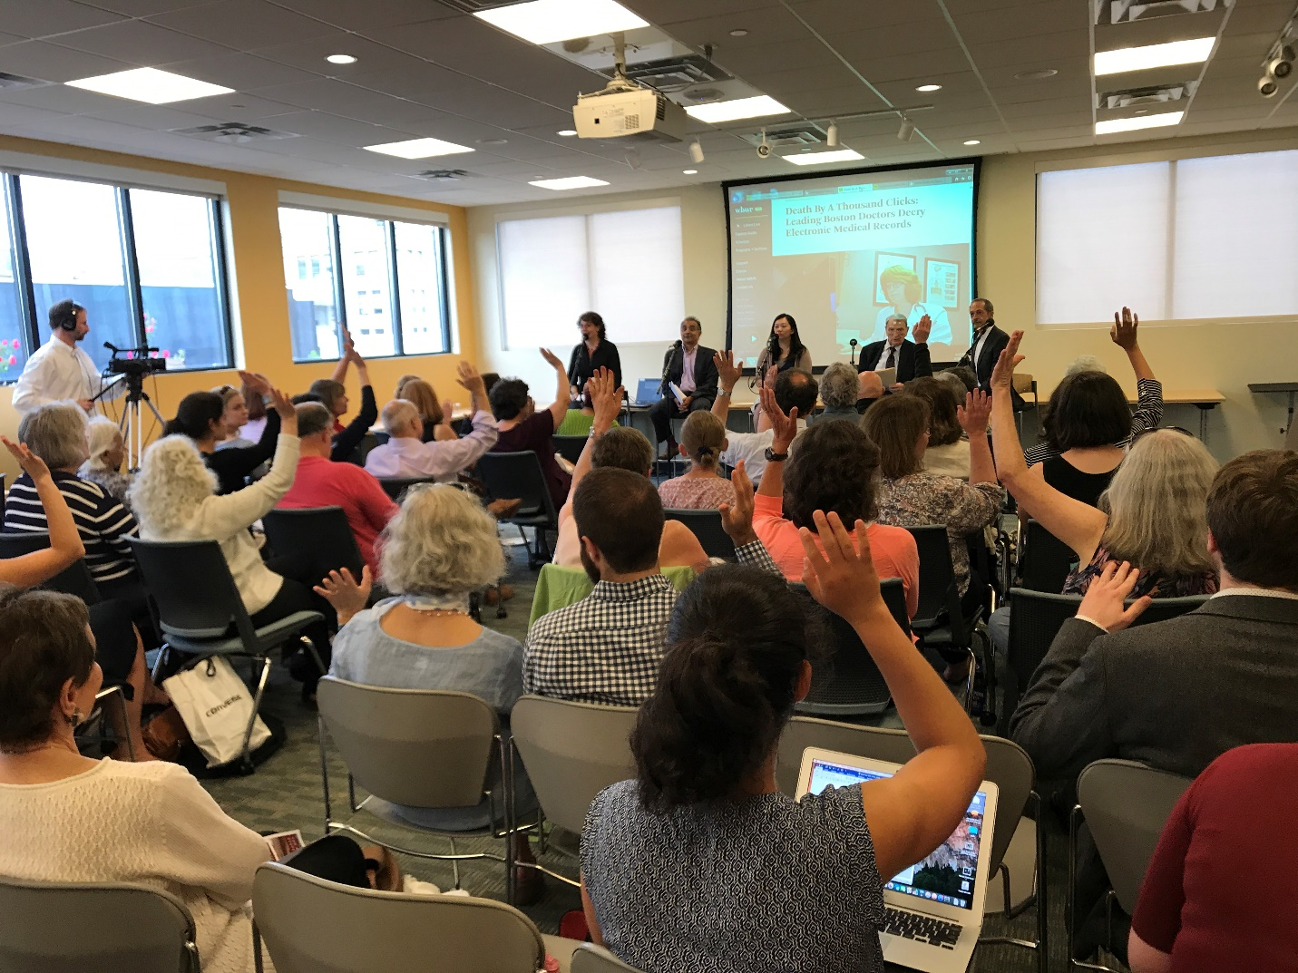

Start 2 months before the event!

Decide on the Goal of the Event:
Your goal might be to pressure stakeholders or decision-makers, visibility for insulin pricing, recruitment, etc. All of these goals might be appropriate, but it’s important to prioritize one specific goal for the event before moving forward.

Decide on the Topic
Here are some examples of Town Hall topics chapters have used in the past:
- Why is insulin so expensive, and what can we do about it?
- What are pharmacy benefit managers? How do they impact drug prices?
- What are the problems with electronic health records and how can we address them?

Decide on Speakers (make sure your speakers represent diversity in terms of race, gender, age, clinicians and patients, etc). It is important for all of these people to share their personal stories.

Example for insulin:
- People living with Type 1 diabetes
- Family members or close friends of people living with type 1 diabetes (mothers especially are compelling)
- Physicians, Nurses, Social Workers, or others who care for diabetic patients
- Have one member of the leadership team end the presentations with a brief overview of the RCA using a few of the central slides (which can be found XXX). This person should also be able to facilitate a conversation with the full group of audience members and speakers.

Decide on the Location.
Some examples are:
- Church meeting room
- School auditorium
- Hospital amphitheater
- Town square
Tip from Fred: For each event change the location to bring in a new population of activists. We held our first meeting in a church to attract the community, the second in a medical school auditorium to attract professional healthcare students, nurses, social workers and doctors. The third meeting was held in the student union to attract undergraduate students and our fourth gathering will be near city hall at a public square.

Decide on a time

Figure out who your audience will be and pick a time that is most accessible for them.
- Weekends from 1-2pm might be is best for parents because this time doesn’t conflict with children’s sports. This time also tends to immediately follow lunch.
- The elderly do not like to travel in the dark; therefore evening meetings should usually be avoided if you are inviting elderly folks.
- Weekdays starting at 5:30pm may work best for people who work 9-5 jobs. If held later people will want to be home. If earlier people won’t be able to get out of work.
- Weekdays starting around 6:30 or 7pm could be best for clinicians who need time to finish seeing patients and for students getting out of class.
- *The event should usually only last one hour. If it is longer, you will lose your audience:

Decide on possible dates
- Pick several dates and then provide these dates to your speakers and give them a choice. If you present them with one specific date many will not be able to attend.
- Alternatively, if you have one featured speaker give them the option of picking a specific date around the times your leadership committee thought would be reasonable.

Book the location:
- Once you have secured a date and time for your speakers then book the location. Many sights will charge money – $150-300 is reasonable (clean up, unlock, supervision etc).
- You can fundraise this money from your chapter’s leadership team. At the event, pass around a hat or bucket (an old coffee can is perfect!) to ask participants for some money to cover space, food, and any other costs.

Begin publicity:
As soon as you’ve decided on the date, time and location, create a flyer. You can get a template RCA flyer by emailing organize@rightcarealliance.org

One month before the event
- Contact newspaper, contact TV, contact your NPR station.
- Contact politicians and other local celebrities you want to attend. They may require earlier notice 2-3 months before the event.
- Create a Facebook event, promote via Twitter, Facebook, LinkedIn, and other social media. Create a hashtag or use an existing one if applicable (ex. #insulin4all)
- Have RCA create an event for you on the RCA website and promote.
- Divide roles for your team, including a media outreach person to contact local media, a logistics person to make sure the space is available and gets any supplies ready, an accessibility person to make sure accessibility needs of the participants and speakers are met.

3 weeks before the event
- Send your flyer to your email list.
- Send out a second time at 1.5 weeks and then again 4 days and the day before the event.
- Ask people to post the announcement and to send it around to their groups and friends.
- Reach out to Senior Citizen Groups.
- Reach out to Student Groups.
- Reach out to any other community groups you want to come.
- Identify other mailing lists.
- Continue promoting via social media.
Tip from Stephanie: Invite people to come by phone or in-person conversations – email should be additional to phone but not instead of. When you are inviting people to come, don’t just mention the event but specifically ask people if they can come. If they say yes, ask them to come early to help set up or if they can bring some food – people generally love to help when they can! If they say maybe, troubleshoot what is holding them back and offer to help. You can arrange a carpool for them, make sure childcare is available at the event etc.

- The accessibility person should be in touch with people who have RSVP’d for the event and anybody who speaks about needing accommodations. You can try to find an ASL interpreter (they may cost money), make sure that the space is accessible to wheelchairs – or it is not, list on your materials and Facebook page how many stairs are involved, you could print documents in larger font. Etc. Reach out to organize@rightcarealliance.org with any questions about this.

Encourage all leadership members to conduct one-on-one meetings (ask for 3 per member) to encourage their friends to attend and have each member of the leadership team bring at least one friend. (If you want to turn this into a contest, write to organize@rightcarealliance.org and we’ll send a prize to the member of your leadership team who recruits the most people.)

2 weeks before
- Hold a leadership meeting to assure all details have been considered and that you’re on track.
- Reinforce the importance of one-on-one meetings and phone calls.
- Have flyers printed out and give some to all the leadership members for them to post at various locations.
- Continue promoting via social media.
1 week before
- Check in with your speakers to discuss the content of their presentations and the timing.
- Be sure to leave a minimum of 15 minutes at the end for audience participation
3 days before
- Hand out flyers
- Hang up posters at high-visibility locations.
1 day before
- Send a final announcement to all your mailing lists, and include the jpg image of your flier
- Send an email reminder to the leadership team and the speakers.
- Have the speakers send their content electronically. Review the content of the speakers to assure there is not significant duplication and to assure that the content will fit into the time they are allotted. Ask each speaker for a brief biography and these will be provided to the team leader designated as the moderator for the meeting.
Tip from Fred: I have chosen student leaders to moderate to give them experience and this increases their commitment.

- Call everybody who has RSVP’d to make sure that they are coming. People are most likely to flake out in the hours before an event, so call everybody either the day before or the day of. Make sure they have the address and directions, and tell them how excited you are that they can come.

Running the Town Hall Meeting
- Make sure the leadership team will be wearing their RCA tee shirts (you can get them at rightcarealliance.org/patients-profits-t-shirts/ or just search online for “Right care alliance t-shirts”
- Check with the speakers if there is anything else that they need.
- Print out the RCA signup sheets and place these at the front entrance of the meeting on a table and assign one member of the leadership team to the signup table to greet each attendee and to ensure that everyone signs in.
Tip from Stephanie: Make sure to write 2 names on the sign-up sheet before the event starts. This way your attendees won’t feel like they are the only ones signing up. I usually list my relatives, and you can list the RCA staff and leadership names if you want.

- Arrive at least 30 minutes before the event, load the presentations on the computer, set up the signup sheet table.
- Bring in any food you’ve arranged.
- Place direction signs to ensure that attendees can easily find the location.
- Have the designated moderator escort the speakers to the front of the meeting hall.
- Usually about 5 minutes past the hour the moderator kicks off the event describing the purpose of the Town Hall Meeting and introducing the first featured speaker.
- The moderator than introduces the next speaker. You can give the featured speaker 15 minutes, and other speakers 10 minutes (adjust depending on how many speakers you have).
- Watch the time closely to assure there is at least 15 minutes of time for open discussion.
- Have the moderator ask, “Who would like to comment?” or “What ideas do you have about lowering insulin prices in the audience?” Call on each raised hand and encourage the speakers to interact with the audience and share their wisdom.
- Upon completion of the question and answer period, the moderator should thank everyone and make sure everyone signs the sign-up sheet. Let participants know they will be contacted in the near future.

Celebrate the success
Have a dinner or hangout with your leadership team 1-2 weeks following the event to debrief and celebrate the event!

