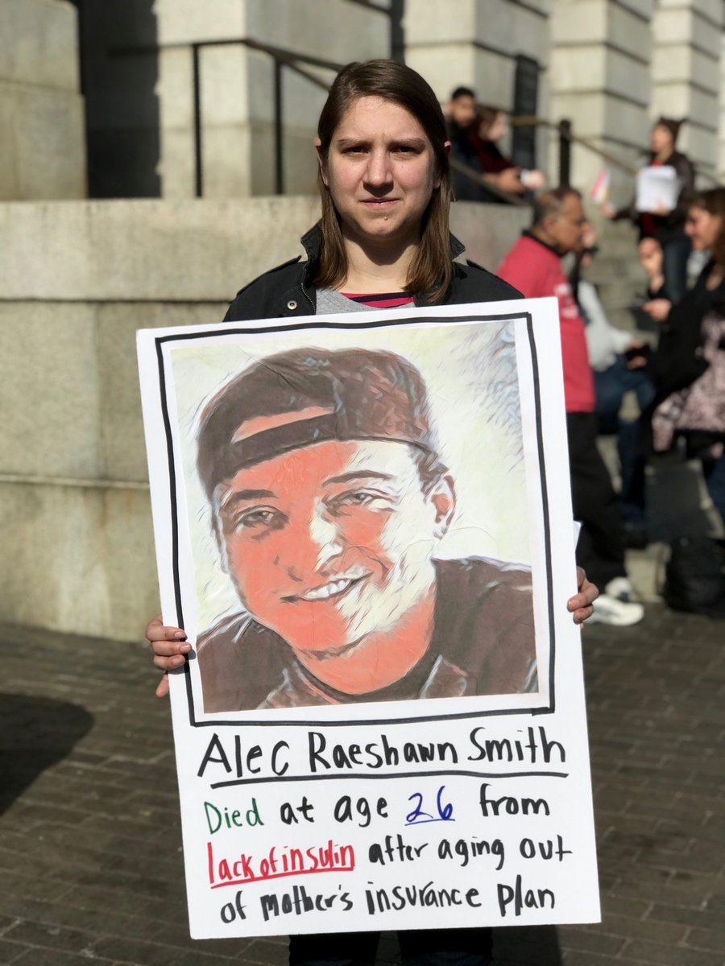
Insulin Day of Action Toolkit

No mother should have to bury her child because they can’t afford insulin. Insulin was first made available nearly one hundred years ago, but young people today are dying from lack of access to this life-saving drug.

On the day before Mother’s Day, Saturday May 12, we are holding pharmaceutical companies accountable for putting profits over people’s lives. We are holding marches, rallies, and listening booths in cities throughout the country. At these events we will collect signatures for Mother’s Day Cards to deliver to the offices of insulin manufacturers, featuring stories of mothers who have lost their children because they couldn’t access insulin.

Join us in organizing an event in your community! Whether you’re a new health care activist or a seasoned organizer, this guide will walk you through the steps to put together your very own event.

Types of Events

We are encouraging chapters to hold one of these events, depending on their interest and capacity:

- Rally/demonstration - This is a fired up protest, with speakers, chants, and signs. This event is the most impactful and exhilarating, but takes a high degree of preparation.
- Listening booth - Create a table in a public place and invite people to talk with you about high insulin prices. This event takes less preparation.

Talk with your fellow chapter members to determine what kind of event you would like to do. There is a guide for how to organize each event in this document.

At BOTH events we will be encouraging folks to sign a Mother’s Day Card, which you can print from our website. After the event, send your card to RCA Headquarters. We will be delivering the cards to offices of insulin manufacturers in the week following May 12.

When you know what event you want to do, go to our website to sign up and let us know what event you are doing so we can support your group. If you have no idea what you want to do, reach out to us at organize@rightcarealliance.org and we can talk through it together.

******************************************************************************

Guide to organizing a Rally/Demonstration

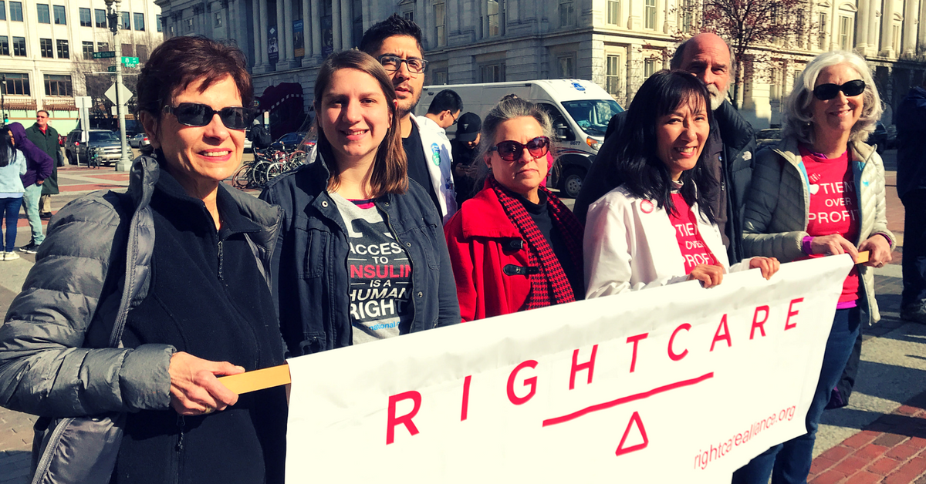

Preparing for the event

To prepare for this event, you will need to review the program, conduct outreach, reach out to media, and prepare supplies. Ideally there are a few people working together and supporting each other in each bucket.

Program

Several people should be in charge of creating a plan for the event and make sure everyone is prepared.

- Review the program in the toolkit (see Program section below). Decide what you like and want to keep, and if there are sections you want to cut. If you don’t have enough people for all of the roles here, then shorten the action of have people speak multiple times.
- Identify speakers, and work with them on what they are going to say. Ask them for a draft of their remarks a few days before the action so you can make sure they are prepared, consistent with the message, and so you can brainstorm with them any challenges. Speakers should be diverse in terms of identify (race, gender, age, ethnicity) as well as role within the health care system and relationship to insulin (patient advocate, nurse, friend of somebody who has Type 1 Diabetes, physician, etc)
- Choose if/what you want to add anything. Direct actions can be incredibly creative. You could add a march, a die-in (when everybody pretends to die and lies on the ground for a few minutes), a dance party, a skit about pharma CEOs being filthy rich, and so much more.
- Besides speakers, identify people to play the other roles.
- Coordinate a poster-making party, when everybody gets together to make the portraits. (Please take and send photos of this!)

Outreach

Your goal is to make sure that people come to the action! The most effective way to increase attendance is by personally inviting people to come. Make phone calls to friends and family members, and ask in person if people will come to this rally. Explain why this rally is important to you, and ask if they feel the same way. Ask these people if they will help with the rally by bringing more people, making a poster, or playing a role.

Other methods of outreach are passing out flyers, creating a facebook event, sending emails to people in your network, reaching out on other forms of social media.

Be sure that you are communicating with RCA Headquarters about your plans so we can help you promote your event!

Media:

Your goal is to reach out to members of the press and invite them to come. You can use the template press alert (download from our website) and include the talking points below. Be sure to follow up the press alert with phone calls multiple times a week in the weeks and days leading up to May 12.

For more resources, use the fact sheet and flyer (you can download from our website), and talking points below.

Talking points:

- No mother should have to bury her child because they can’t afford insulin. Insulin was first made available nearly one hundred years ago, but young people today are dying from lack of access to this life-saving drug.
- On the day before Mother’s Day, Saturday May 12, we are standing up against the pharmaceutical companies who have put profits over the lives and well-being of people with diabetes.
- Insulin is a hormone that helps turn blood sugar into energy. People with diabetes take insulin because they have insulin deficiency or resistance. As many as 3 million Americans with Type 1 diabetes and 4 million with Type 2 diabetes require insulin to maintain their health.
- As many as 7 million Americans depend on insulin to stay healthy, and 3 million need it to survive. The price of this essential drug has tripled over the past ten years, making it unaffordable for many Americans. Last year, at least three young people died because they could not afford the insulin they needed to live.
- The “Big Three” insulin companies - Eli Lilly, Novo Nordisk, and Sanofi - raise prices to whatever the market will bear, unrestricted by regulations or competition from generics
- The price of insulin has tripled in the last ten years. People with Type 1 diabetes can spend up to $1400 a month on insulin alone!
- For those who depend on it, insulin is like oxygen. Big pharma is killing Americans by raising the price of insulin!

Supplies: (The printed resources can be found on the RCA Website)
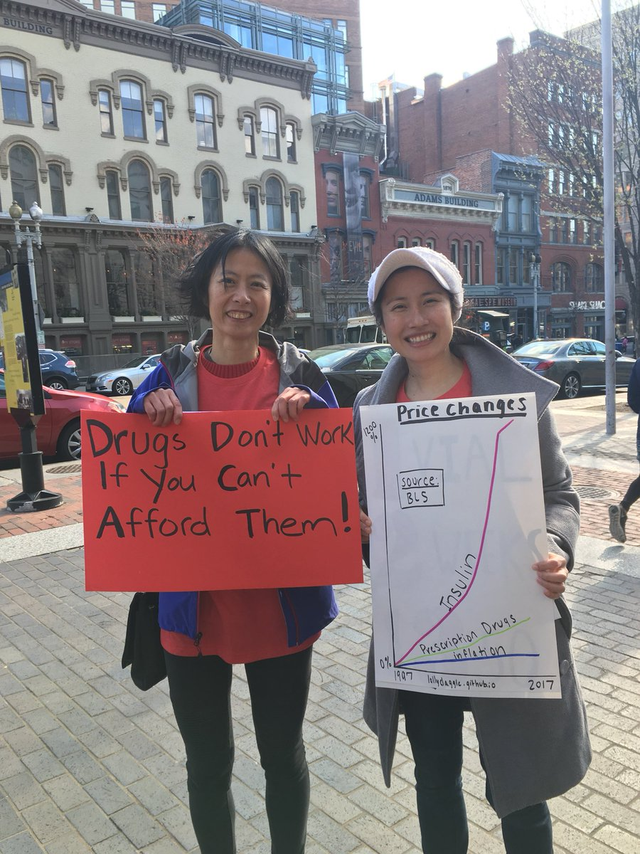
Portraits and signs
Mother’s Day Card
Sign-up sheet
Printed Flyers
Printed agendas of the action
RCA Banner - We have a few extra banners we can send, contact organize@rightcarealliance.org if you would like one.
Bullhorn or Megaphone (if you have one)

Event program

Here is a sample program for an Insulin Day of Action rally. Feel free to adapt to fit your own creativity and resources, but be sure to always double-check your information for accuracy, and be respectful of the people whose stories you’re sharing.

Roles

(If you don’t have enough people to fill all the roles, you can have fewer speakers or have the same person speak multiple roles. You can do this action with as few as three leaders)

MC = the MC is the main speaker, who takes the mic in the beginning and end and introduces other speakers throughout. The MC leads chants and figures out when to chant.

Portrait storytellers = these people tell the stories of the people that you’ve made portraits for. The stories are very short and you can read from a script so this is a good role for someone who wants to speak but not have to memorize or give a long speech. One person can read multiple stories if you have more portraits than people.

Speakers #1, #2, #3, #4 = they should all be able to speak passionately about why insulin pricing and affordable drugs are important to them. At least 1 speaker should be insulin dependent. If you can’t find anybody to speak in your area with diabetes, please contact organize@rightcarealliance.org and we’ll help you find somebody.

Ideally 2 of the speakers are clinicians and 2 are patient advocates, but they can also be family members or loved ones, researchers, lawyers, or anybody else who cares about and has a connection to this topic. At least 1 of the speakers, and maybe more, should talk about how the pharmaceutical companies of Eli Lilly, Sanofi and Novo Nordisk could be selling insulin for less money but chose to keep the prices so high for their own greed.

Final Speaker = could be the same as the MC, this person should be one of the organizers of the event. They thank everybody for coming and talk about how much more we have to do together, but how this is a collective fight that impacts all of us. They encourage people to sign up to get more involved, and give directions for a group photo that happens when they are done speaking. Close out the action with some chants or a song.

Stage Manager = they keep very close track of the agenda. This person goes up to all of the speakers right before it is their turn to speak. This person should probably not have a speaking role so they can make sure everything is on track.

Portrait Holder = this person holds the portraits for the speakers. Perfect role for somebody who wants to be visible but doesn’t want to speak.

Clipboard Captain = this person is in charge of approaching and talking to everybody in the crowd, handing out flyers and asking them to sign up. This person needs to be able to act confident and outgoing, even if they feel shy and nervous inside! This person should approach passersby, explain what we are doing, and hand them a flyer. They ask everybody to fill out the sign-up sheet. Ideally there are about 3-5 people in the crowd with clipboards, but at least 1 needs to be identified ahead of time. The Clipboard Captain should check in with the other clipboard recruiters throughout the action to talk about how they are doing.

Photographer = this person takes photos constantly - of speakers, of people in the crowd, of everybody. After the action make sure to get a group photo, as well as smaller group and individual photos of people with their signs.

Videographer = this person takes a video of the rally, which can be posted on social media

Portraits

Here is a list of portraits that Right Care Alliance members have made for past events on insulin prices. Please feel free to make more portraits for people in your group, or who know someone who is insulin dependent (or for a pharma executive who has made insulin inaccessible). The photos are all available for download on the RCA Website.

You should try and make as many portraits as you can, given your group’s time and resources. If you can’t make that many, prioritize making posters of the people who died from lack of access to insulin, and next make photos of those who are dependent on insulin and are affected by high insulin prices.

- Shane Patrick Boyle (deceased)
  - My name is Shane Patrick Boyle. When I moved to help my dying mother, I lost access to insulin. I started a GoFundMe campaign. But fell $50 short of what I needed. My mother died in March 2017. I died two days after her. I died because I could not afford my insulin.
- Alec Raeshawn Smith (deceased)
  - My name is Alec Raeshawn Smith. When I turned 26, I aged out of my mom’s insurance. I could NOT afford the $1,300 a month. I needed for my insulin so I rationed what I had left. I died in June 2017 because I could not afford my insulin.
- Antavia Worsham (deceased)
  - My name is Antavia Lee-Worsham. My insulin and equipment cost nearly $1000 a month. I was struggling to afford it. Last April my brother found me collapsed in the house. I died from diabetes at 22 years old.
- Alonda Lewis (insulin dependent)
  - My name is Alonda Lewis and I am insulin dependent. I was hospitalized three times during my pregnancy. My hospitalizations cost $42,000. The reason it cost so much is because my insurance provider would NOT cover the much cheaper and more effective type of insulin I needed to keep me and my baby healthy.
- Deidre Waxman (insulin dependent)
  - My name is Deidre Waxman. I am 65 years old and have Type 1 diabetes. Because Congress won’t let Medicare negotiate a better price. My insulin costs $500 in the US. I get my insulin illegally in Canada, where it costs $60 a month.
- Chris Noble (insulin dependent)
  - My name is Chris Noble. I’ve had diabetes since I was very young. 100 years ago, before insulin was discovered, kids like me died. Recently I had a gap in my insurance. I knew how dangerous it was to ration my insulin but I had to do it until my new plan kicked in.
- Carol Ezell (insulin dependent)
  - My name is Carol Ezell. I’ve had diabetes for 25 years. The same insulin I took back in the 90s is now triple the price. I’m in my 60s and ready to retire. But instead I had to get another job. Because my insulin and supplies are so expensive
- Alex Azar (Pharma)
  - My name is Alex Azar. As President of Eli Lilly, USA, for 5 years, I doubled the price of insulin. For this crime, I faced no consequences. Instead I was appointed as Secretary for Health and Human Services.
- David Ricks (Pharma)
  - My name is David Ricks. I am the current CEO of Eli Lilly. While people died last year because they could not afford their insulin, I made $14 million dollars and my company took in $20 BILLION.

Chants:

These chants can be used for if you are marching, or if there is time between speakers or between sections. The MC or whoever has the mic should lead the chants. If you plan on using chants, be sure to practice the chants with your group beforehand so everyone knows how they go. Feel free to make up your own chants as well!

- Insulin is oxygen/ don’t let us die again
- Hey hey, ho ho/ price gouging has got to go
- You’re killing us with high priced meds, without insulin we’ll end up dead
- A patent sold for three bucks / makes pharmacy millions/ but we’re out of luck
- Show me what democracy looks like / this is what democracy looks like
- You got my back / I got your back
- When Type 1 lives are under attack / what do we do?/ stand up, fight back!
- Hey Hey Ho Ho/ High Drug Prices Gotta Go

Agenda

This is a sample agenda, from the DC rally in April. Feel free to adapt or switch the order of portrait stories and speakers as it makes sense with your rally. If you would like to see how the rally looks in real time, you can watch a video of the livestream here.

MC: Welcomes and thanks everybody for coming. Explains about the Right Care Alliance, the insulin campaign and the purpose of this action.

Share Three Portraits (hold up portraits and share the stories of the following 3 people)
- Alex Azar
- Alonda Lewis
- Antavia Worsham (It’s especially powerful to do this as a “call and response” chant)

Speaker #1 shares their story and experience
Speaker #2 shares their story and experience. If you don’t have speaker #2, do some chants

Three More Portraits:
- David Ricks
- Deidre Waxman
- Alec Raeshawn Smith (call and response)

Speaker #3 shares their story and experience.
Speaker #4 shares their story and experience.

Three Final Portraits:
- Chris Noble
- Carol Ezell
- Shane Patrick Boyle (call and response)

Final Speaker (can be the MC or somebody else) - thanks everybody for coming, talks about how we need to keep up the work together. Closes out by leading chants or a song.

After the event, send your Mother’s Day Card with signatures to RCA headquarters. We will be delivering the cards to pharma offices in the week following May 12. Before you send your card, take photos of your Mother’s Day card and blast on social media.

******************************************************************************

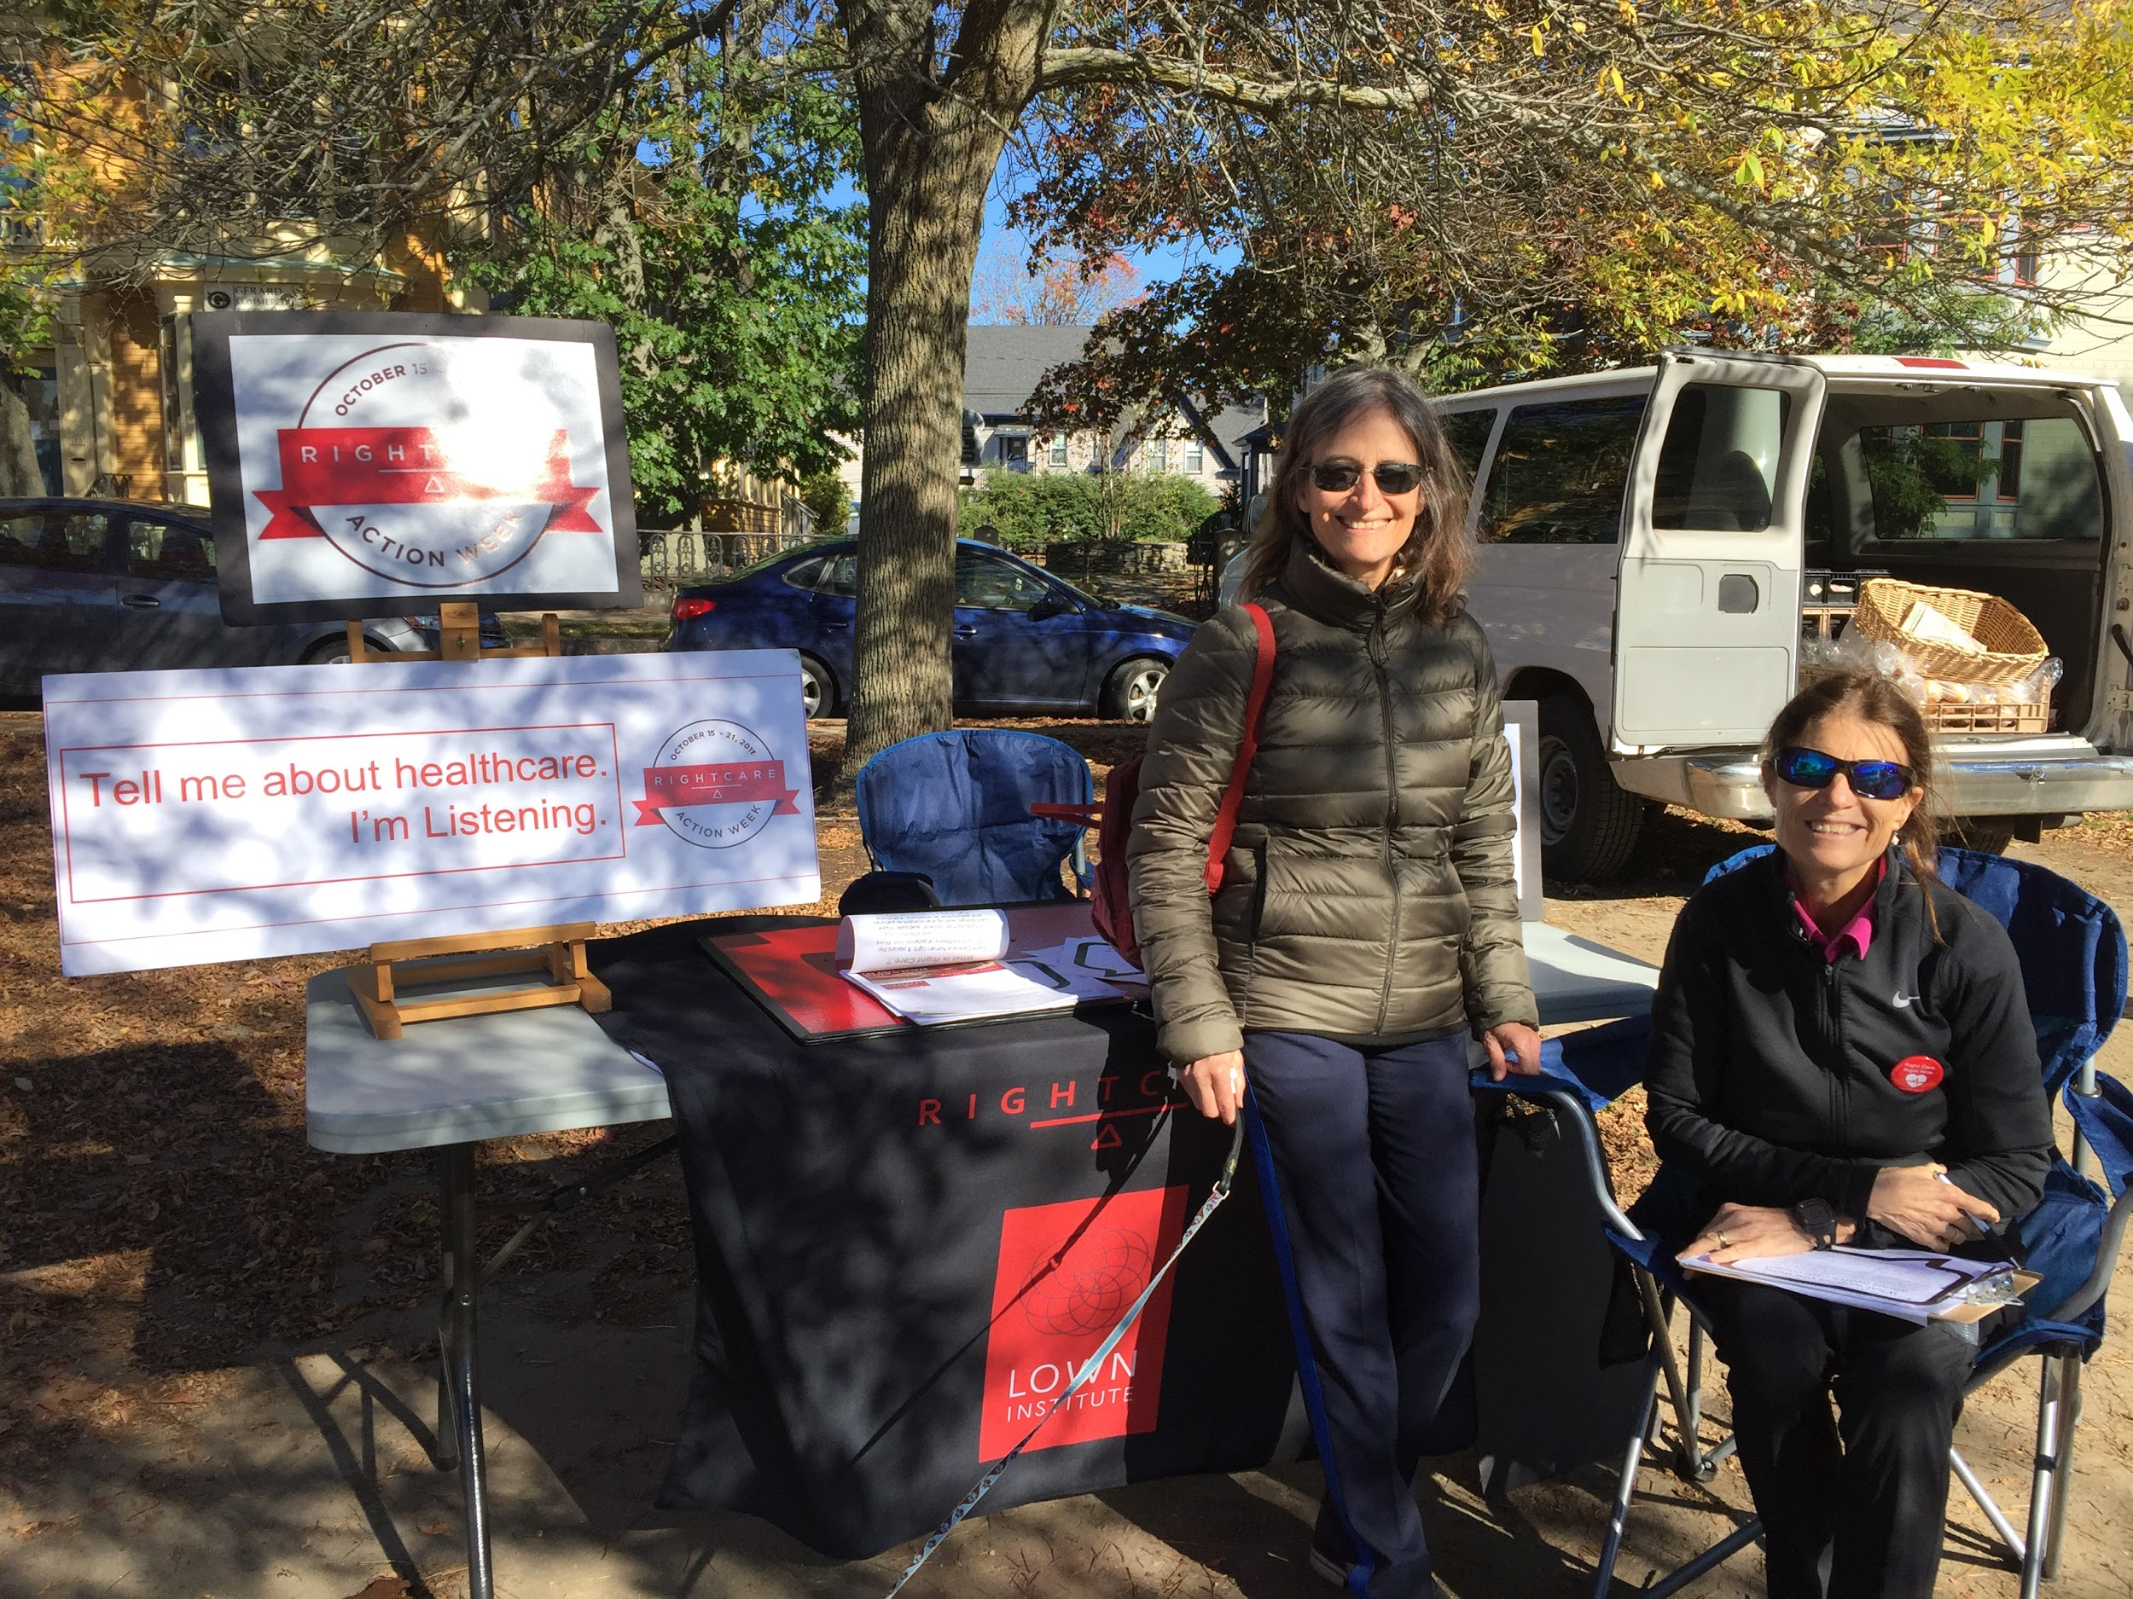
Guide to organizing a Listening Booth

The listening booth is placed in a public place, like a farmers market or public park, and is a space where we invite passersby to share stories and experiences about drug costs. We share our stories, as well as examples that we know of, and talk about people who cannot afford their insulin, even though it is a necessary drug for so many people.

We describe how insulin is unaffordable, and we ask people to sign a large Mother’s Day card written by mothers who have lost their children to diabetes because insulin was too expensive. That card will later be given to pharma executives.

This booth is also a way to find more people who share our values and invite them to take future action together!

Event preparation

Outreach

Your goal is to make sure that people come to the action! You don’t need a ton of people for the listening booth, but you should have at least 2 people managing the table at all times, as well as having a few people walking around with the card and flyers to talk to people and get signatures.

The most effective way to increase attendance is by personally inviting people to come. Make phone calls to friends and family members, and ask in person if people will come to this rally. Explain why this rally is important to you, and ask if they feel the same way. Ask these people if they will help with the rally by bringing more people, making a poster, or playing a role.

Other methods of outreach are passing out flyers, creating a facebook event, sending emails to people in your network, reaching out on other forms of social media.

Be sure that you are communicating with RCA Headquarters about your plans so we can help you promote your event!

Media:

Your goal is to reach out to members of the press and invite them to come. Contact your local newspaper ahead of time to let them know when and where you will be conducting the listening booth, and why this is important.

For more resources, use the Fact Sheet, flyer, and talking points below. The fact sheet and flyer are available on the RCA Website.

Talking points:

- No mother should have to bury her child because they can’t afford insulin. Insulin was first made available nearly one hundred years ago, but young people today are dying from lack of access to this life-saving drug.
- On the day before Mother’s Day, Saturday May 12, we are standing up against the pharmaceutical companies who have put profits over the lives and well-being of people with diabetes.
- Insulin is a hormone that helps turn blood sugar into energy. People with diabetes take insulin because they have insulin deficiency or resistance. As many as 3 million Americans with Type 1 diabetes and 4 million with Type 2 diabetes require insulin to maintain their health.
- As many as 7 million Americans depend on insulin to stay healthy, and 3 million need it to survive. The price of this essential drug has tripled over the past ten years, making it unaffordable for many Americans. Last year, at least three young people died because they could not afford the insulin they needed to live.
- The “Big Three” insulin companies - Eli Lilly, Novo Nordisk, and Sanofi - raise prices to whatever the market will bear, unrestricted by regulations or competition from generics
- The price of insulin has tripled in the last ten years. People with Type 1 diabetes can spend up to $1400 a month on insulin alone!
- For those who depend on it, insulin is like oxygen. Big pharma is killing Americans by raising the price of insulin!

Supplies: (The printed resources can be found on the RCA Website)

Mother’s Day Card for people to sign
Sign-up sheet
Printed Flyers
RCA Banner - We have a few extra banners we can send, contact organize@rightcarealliance.org if you would like one.
Small table or stand (music stand, card table, something easily portable but able to hold the sign to create a sense of a booth)
Folding chairs
Tape, pens, markers
Optional- Download and print ~20 "What RightCare Means to Me" signs here.

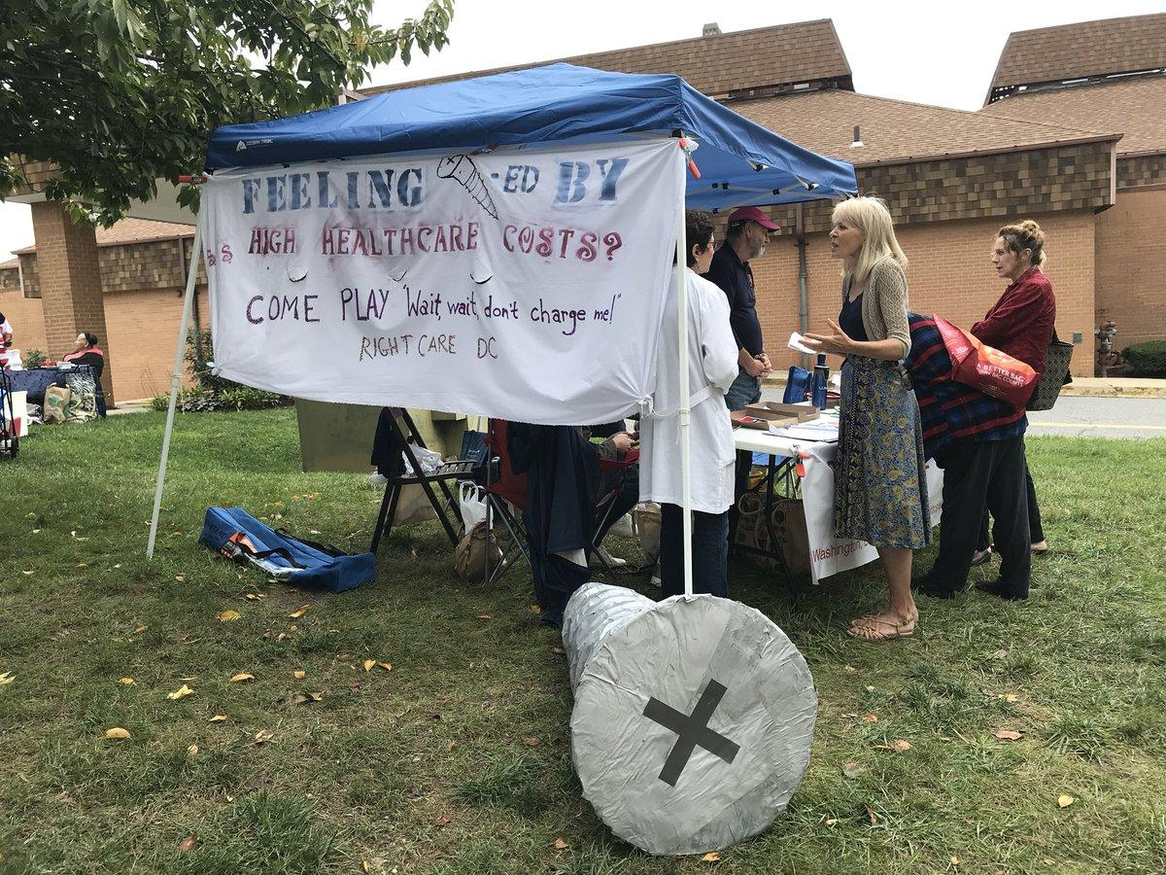

Program
Before the event, prepare a quick introduction. Sample: "Hello, my name is ______ . We think that costs of medicines are too expensive, especially insulin. This is a mothers day card written by mothers whose children died because they couldn’t afford insulin. Will you sign this? Once you’re in the conversation, ask them about their own experiences! Additional questions could include: Have you had to pay out-of-pocket for prescription drugs? Have you changed any of your care because you couldn’t afford it? Do you know people who have?
The day before the event, remind everybody who agreed to staff the table. Remind them that you are excited for them to be there.
Event Program
1. Set up with the table with a Right Care Alliance sign, a some posters of people who died from lack of insulin, flyers, sign-up sheets and the giant Mothers Day card.
2. During the conversation, be sure to share a few sentences about yourself! The best way to build a connection with somebody is to share your story first, so introduce yourself and share why you care about making change in healthcare.
3. Take photos! Don’t forget to use the banners and signs in your photos. Tweet your photos using the hashtags #insulin4all and #rightcare and then share them with us at organize@rightcarealliance.org
4. Keep track of the key themes and stories that emerge from each conversation. After the event, everybody should share their takeaways.

5. After the event, send your Mother’s Day card to RCA Headquarters. We will be delivering the cards to pharma offices in the week following May 12. Before you send your card, take photos of your Mother’s Day card and blast on social media.
Conversation Tips:
- Approach people as they are walking near you. Once they are about 6 feet away from you, greet them and invite them to talk about out of control drug prices.
- Understand that many people will pass by and won’t talk to you. That’s okay and normal. Keep trying, and you’ll find at least a few who are excited to talk with you.
- Smile, work to appear inviting but not pushy. Standing is more approachable than sitting.
- Specific stories and instances are more powerful than simple endorsements
of problems. When someone says “Drugs are too expensive,” ask them what happened to make them come to this conclusion. Keep asking about specifics, for example “Why did you make that decision? So why?”

